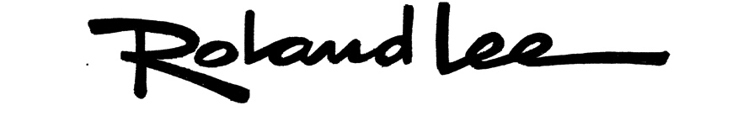
Spring 2016 Watercolor Workshops in St. George
Bio: A signature member of the National Watercolor Society, Roland Lee has been painting transparent watercolors for 35 years. He has written painting articles for The Artist’s magazine and Drawing Board magazine, and been featured in Art West magazine, Western Art Collector, and in several watercolor books including Splash 11 from Northlight Books. He has taught workshops throughout America and was an art instructor at Dixie State University. He was recently awarded the Governor’s Mansion Medal for contributions to the arts in Utah. His original paintings can be found in over 1000 museum, university, and private collections worldwide.
See over 40 free painting demos at www.rolandlee.com/techniques
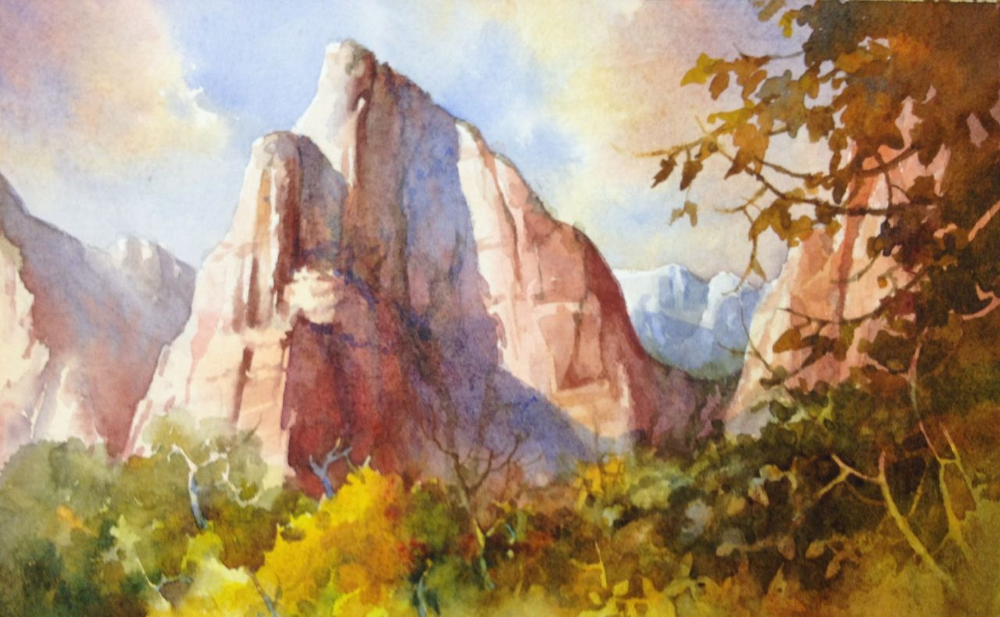
1. Thurs–Fri January 7-8
“Red Rocks & Autumn Leaves” – One of Roland’s favorite subjects, this watercolor workshop will teach you to see the values, edges, and shapes that define the red rock country of Utah. We will also explore using the negative painting technique to depict colorful yellow Fall cottonwoods and golden oaks. We will paint in the studio. Cost $175

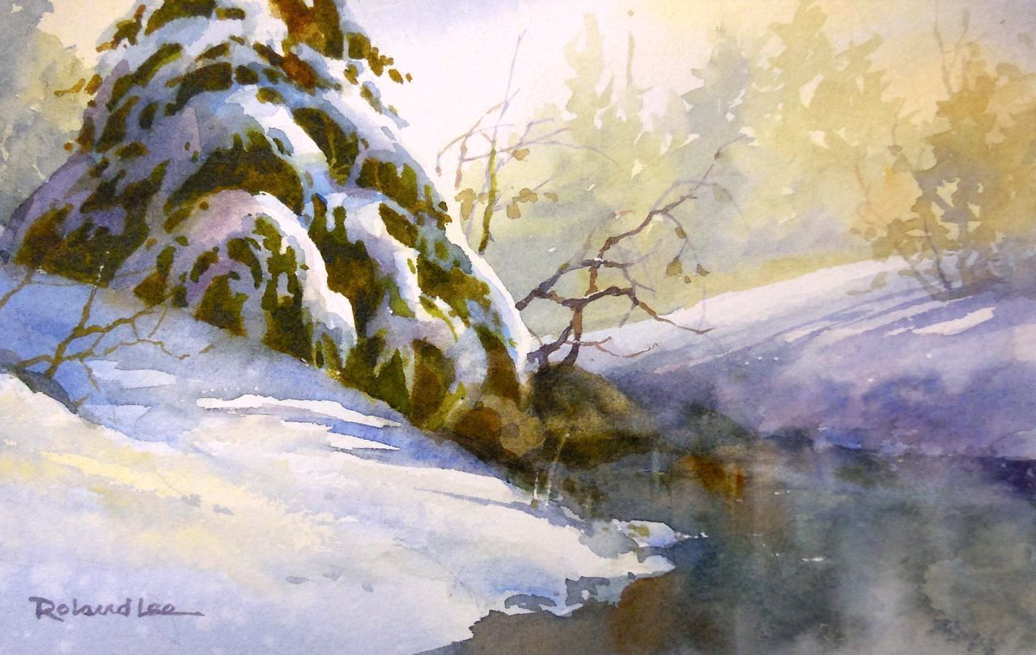
2. Thurs-Fri Feb 11-12
“Rustic Winter Scenes” – Snow is a favorite subject of watercolorists. Learn to use negative painting and wet-into-wet techniques to create the softness and beauty of winter scenes in watercolor. We will explore the contrast of white snow on deep green pines, warm red rocks, and rustic barns. We will work in the studio. Cost $175

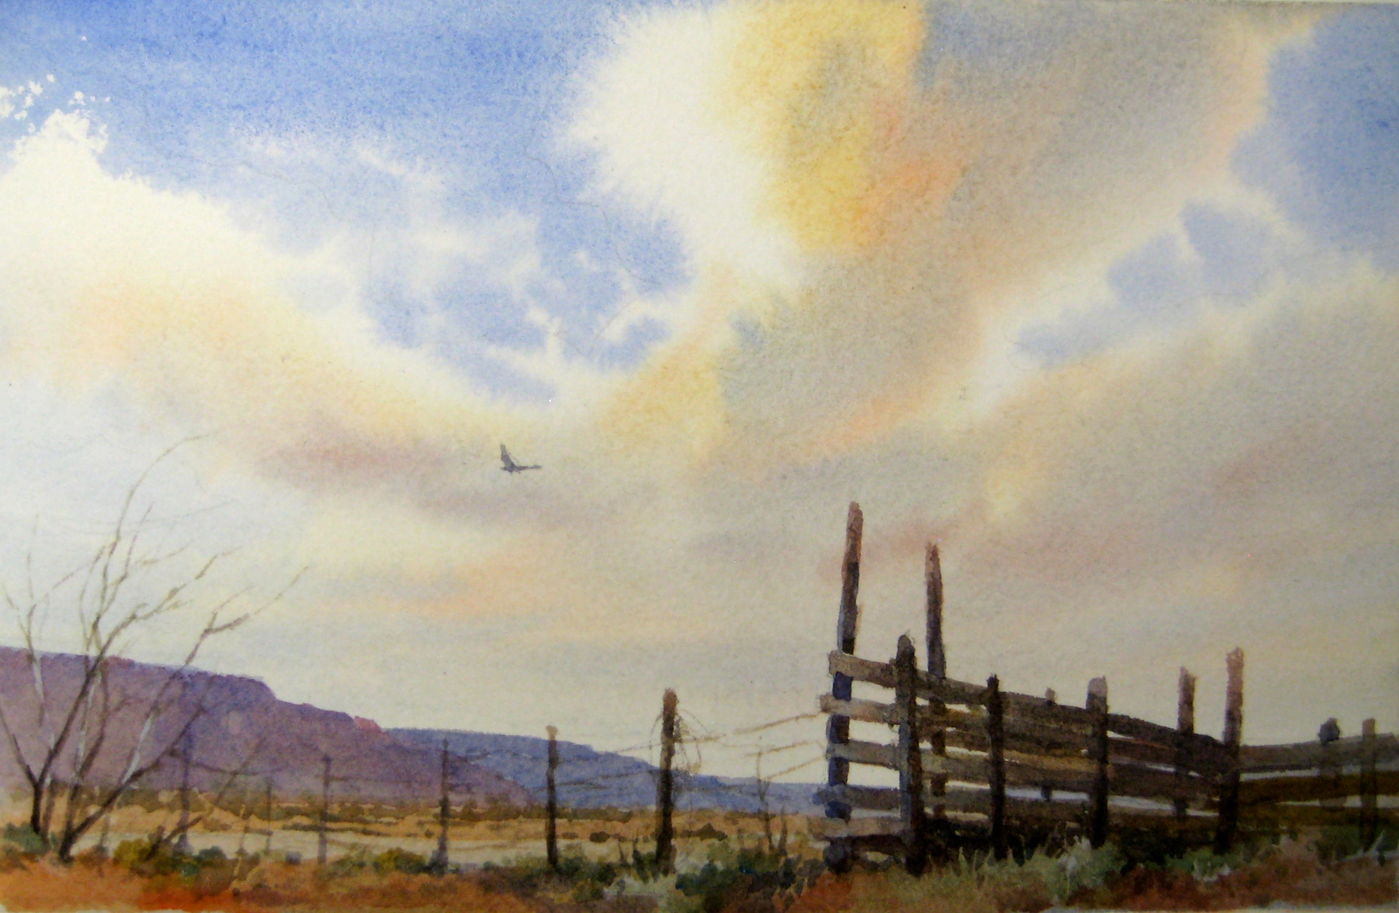
3. Thurs–Fri March 3-4
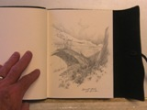
“Big Skies and Deserts” – There is no place on earth that rivals the big dramatic skies of Southern Utah as they billow and grow above the expansive deserts of southern Utah. This workshop will examine the characteristics of skies, and the special techniques watercolorists use to paint them effectively. We will also work on painting sand, desert washes, and desert shrubs such as yuccas and sage.
Cost $175
4. Thurs–Fri April 7-8
“Drawing and On-location Sketching” – Drawing is fundamental to all art. This class focuses on the most important elements in drawing, which are also the keys to making successful paintings. We will learn to see the effects of light and shadow to create mass and form. Roland will teach his on-location sketching techniques and how he uses them to develop paintings back in the studio. We will sketch both indoors and outdoors weather permitting. Cost $175

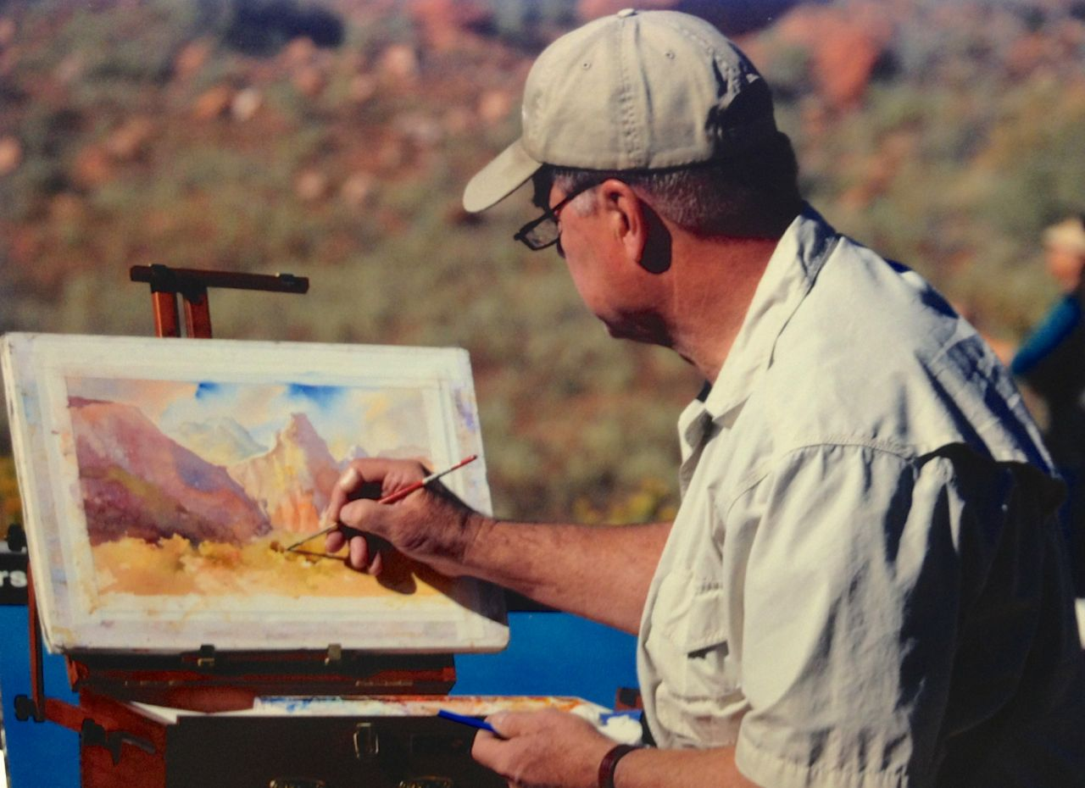
5. Thurs–Fri May 5-6
“Plein Air Painting in Red Rock Country” – Painting outdoors can be both exhilarating and frustrating. While bugs and changing shadows create special challenges, being on-site gives the artist a perfect image to paint from. With a few tips you can get started on the right foot and find the shorthand for dealing with the rapidly changing sun. We will start in the studio but end up outdoors where we will work on plein air paintings. $175

About the workshops: Classes are held at A Passion for Painting. Time is 9am to 4pm each day with a 1-hour lunch break (on your own.) Art class fee is $175 due at reservation. You will receive a full refund if cancellation notice is given 30 days prior to the class. No refunds given after that time.
Cost: $175 for Two Days. 8 student limit
To register contact:
Becky Whitney, A Passion For Painting (435) 628-5890 www.passionforpaintinggallery.com
310 E. Tabernacle, St. George, UT 84770

For materials list go to: www.rolandlee.com/workshops
Roland Lee Studio & Gallery: 165 North 100 East #2, St. George UT 84770 / 435-673-1988
rolandleegallery@gmail.com

